Question 1-Given string is Palindrome or not

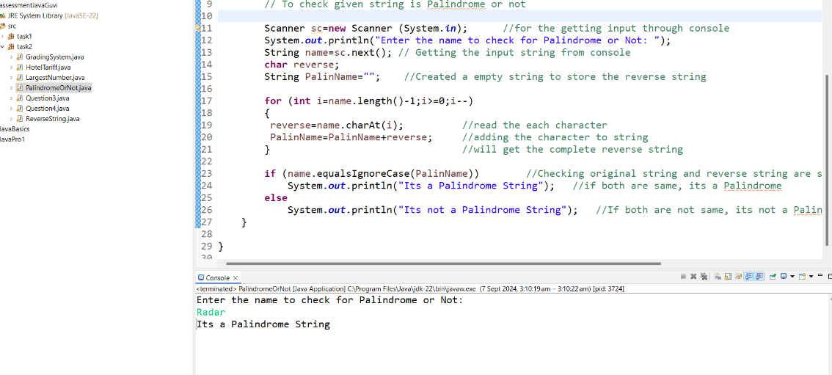

Question 2-Reverse String

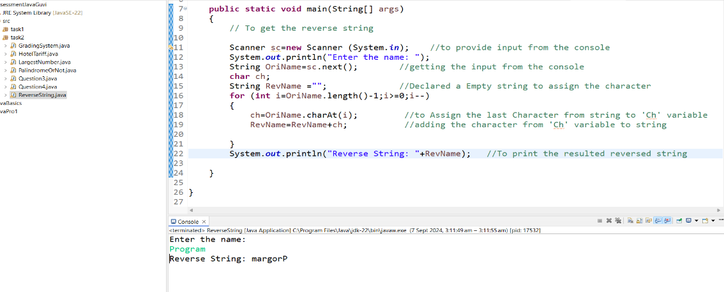

Question 3-Print number as mentioned Pattern

